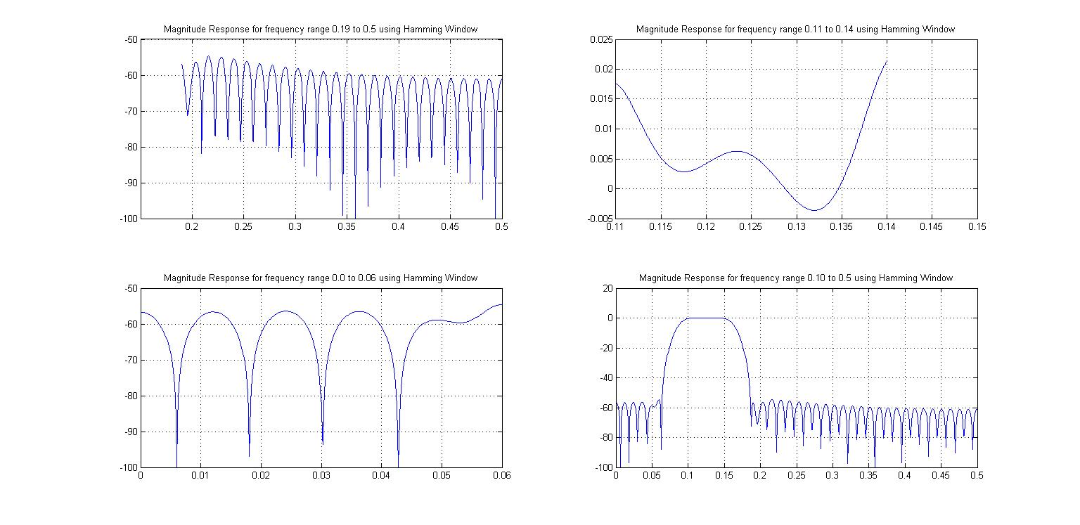**Magnitude Response for Different Freq Range :**

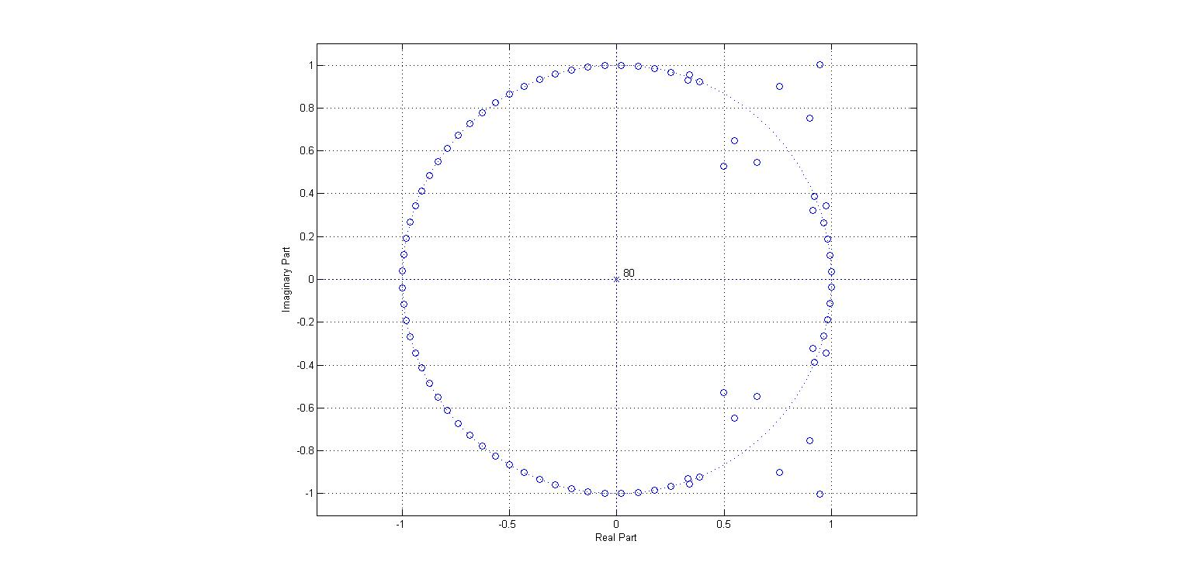**Pole Zero Plot:**